**Spring Framework**

**Name: Akanksha Tyagi**

**Id: 4701**

**Question 1:**

**Program to illustrate the tight coupling.**

carjourney.java

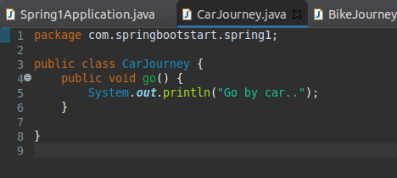

BikeJourney.java

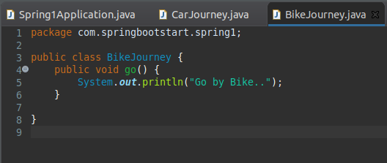

TrainJourney.java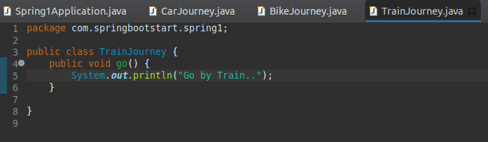

To run these classes, we need to create objects separately.

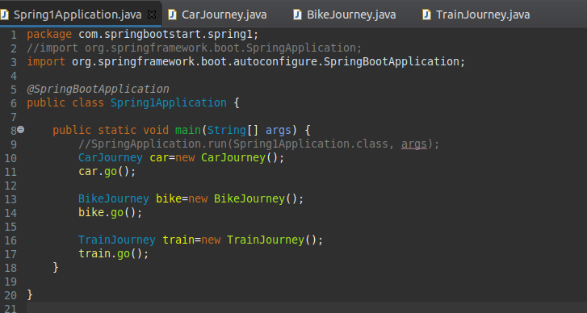

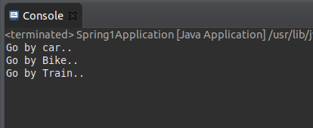

**Question 2:**

**Program to illustrate the loose coupling.**

// interface

Travel.java 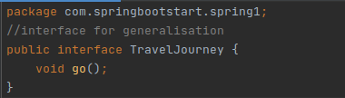

//classes implementing interface

Car.java 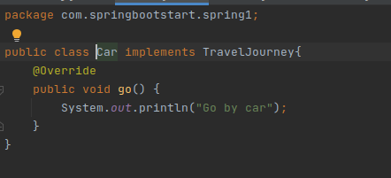

Bike.java 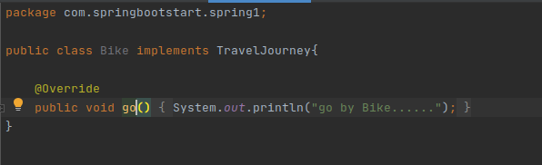

Train.java 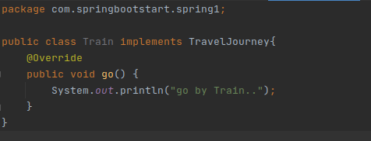JourneyClass.java 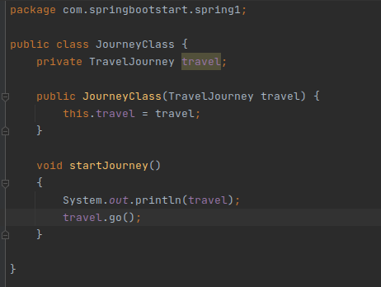

Main class 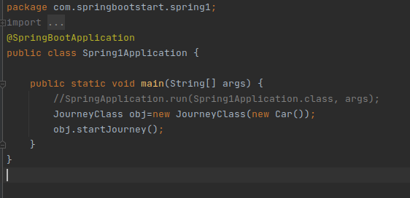

Outputs:

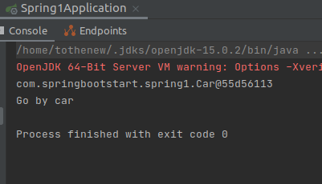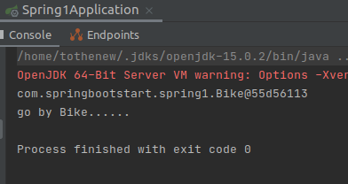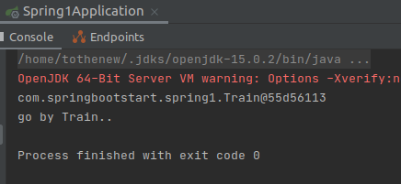

**Question 3:**

**Use @Compenent and @Autowired annotations to in Loosely Coupled code for dependency management.**

Adding @Component to Train class

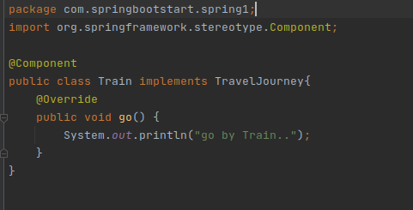

Adding @Component to Journey class and @Autowired to the setter method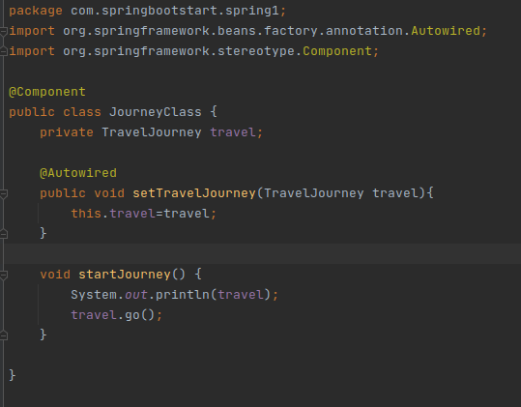

Adding the dependency injection through ApplicationContext

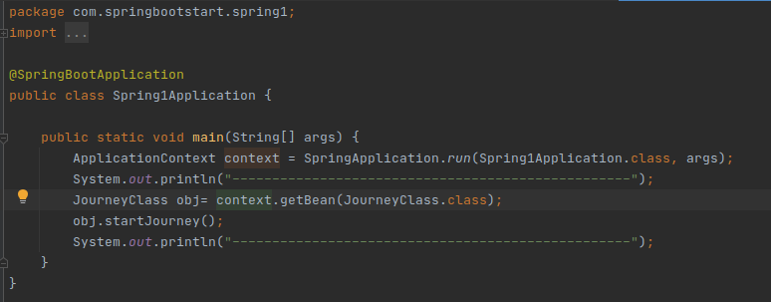

Output: 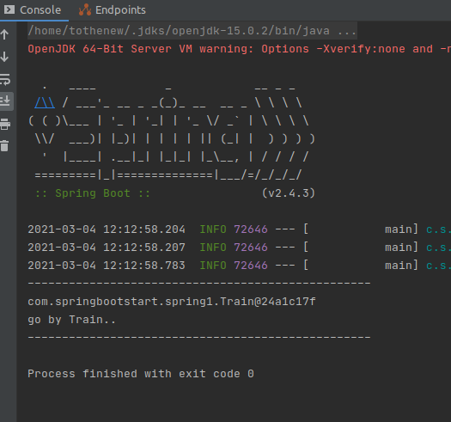

**Question 4: Get a Spring Bean from application context and display its properties.**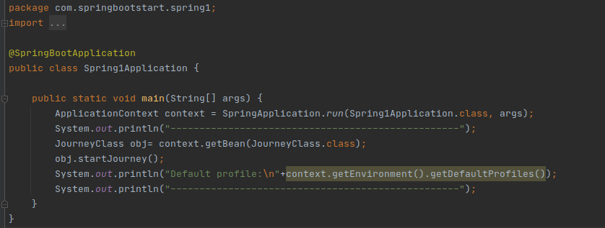

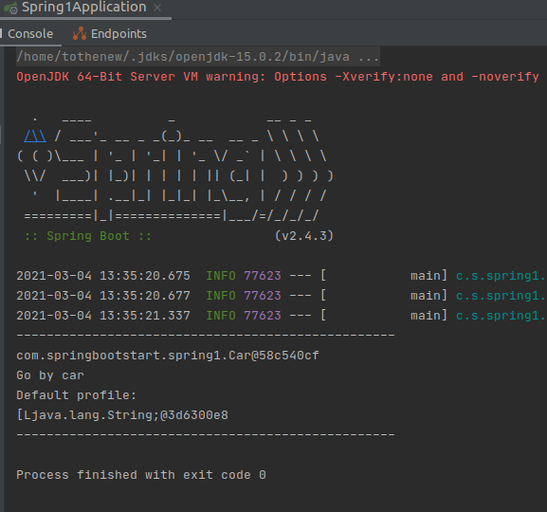

**Question 5: Demonstrate how you will resolve ambiguity while autowiring bean (Hint : @Primary)**

----------AMBIGUITY-------

Adding @Component to train class



Adding @Component to Bike class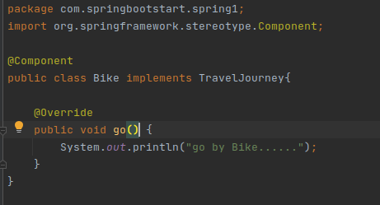

Adding @Component and @Autowired to JourneyClass



Main class

Output:

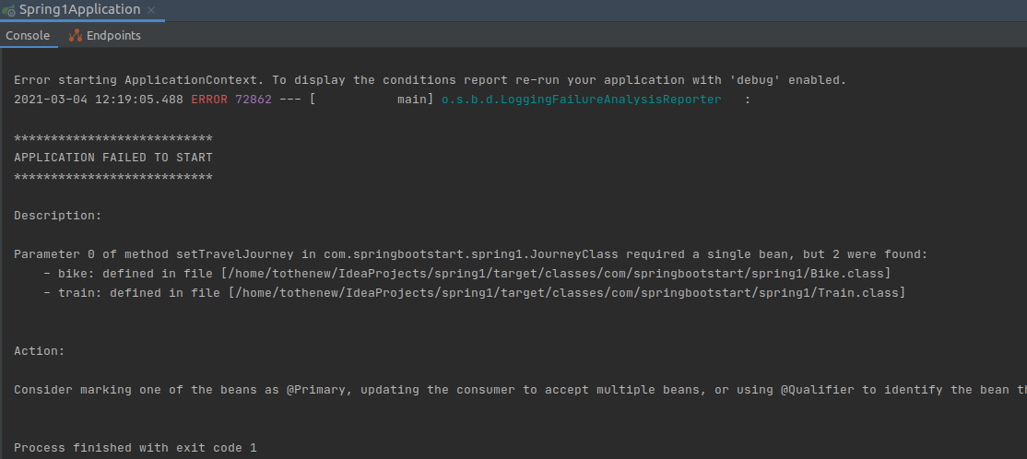

RESOLVING AMBIGUITY

Train Class



Adding @Primary to the Bike Class and the ambiguity is resolved.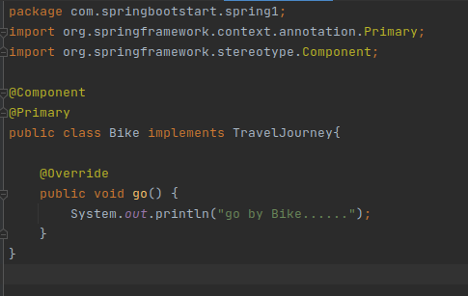

JourneyClass: 

Main class:



Output:

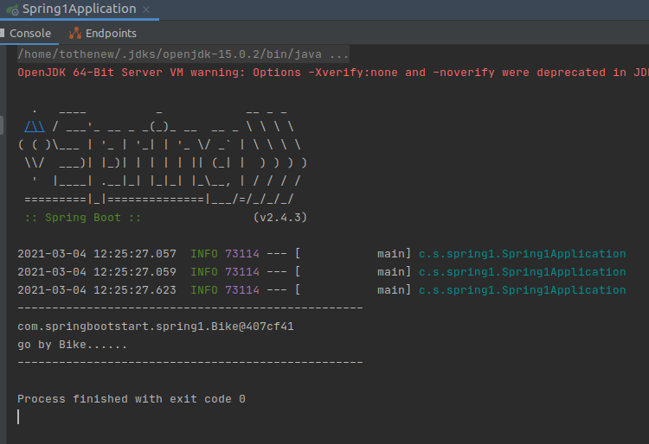

**Question 6: Perform Constructor Injection in a Spring Bean.**

Adding @Component to the car

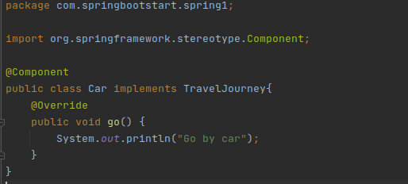

@Autowired on Constructor/ constructor injection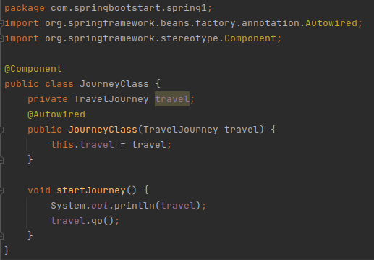

Output:

